**TASK - ANSIBLE IN UBUNTU INSTALLATION**

**Step 1: Launch the Ubuntu instance :**

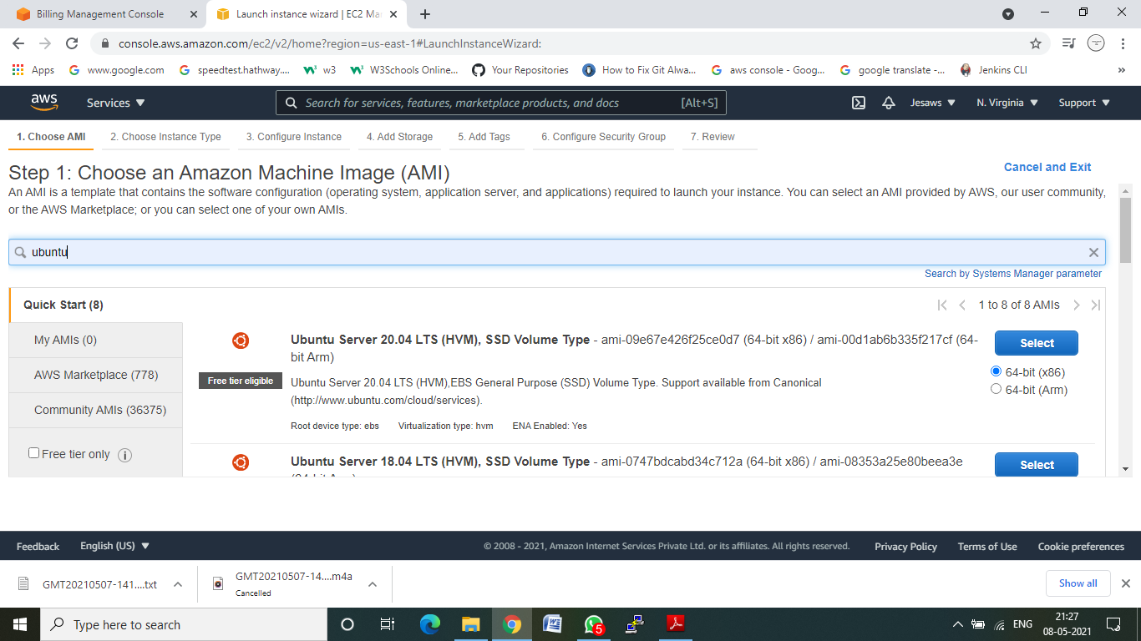

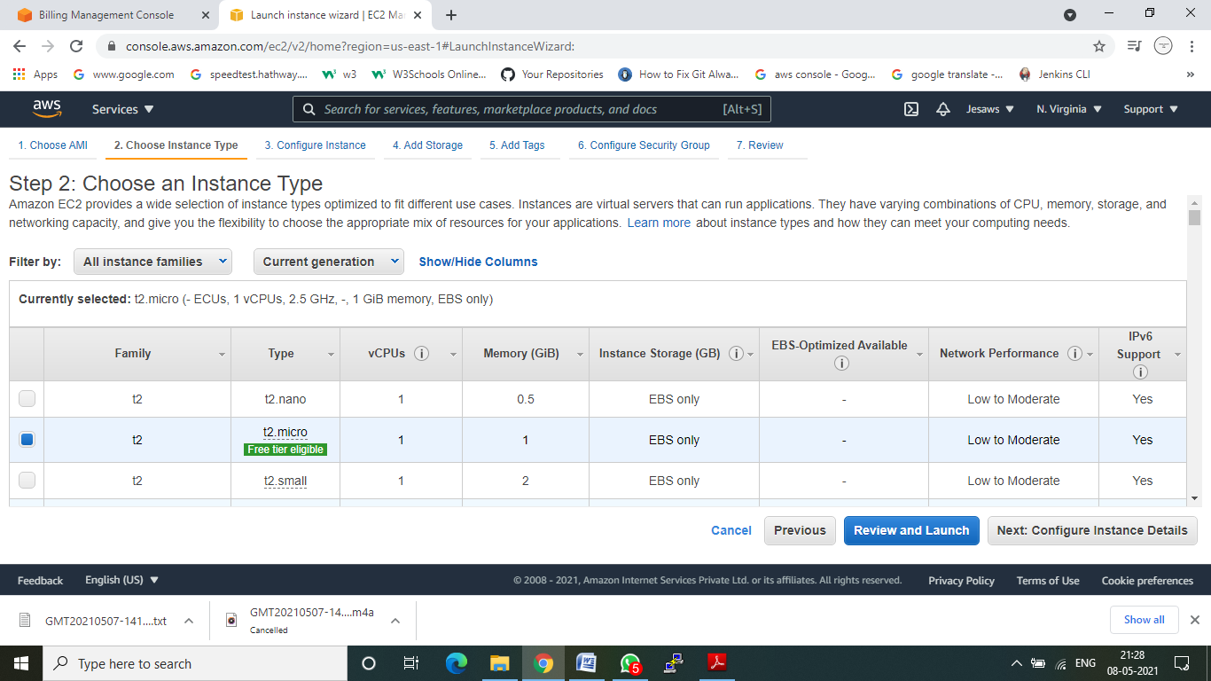

**Step 2: User data**:

#!/bin/bash

sudo apt-get install software-properties-common

sudo apt-add-repository -y ppa:ansible/ansible

sudo apt-get update

sudo apt-get install -y ansible

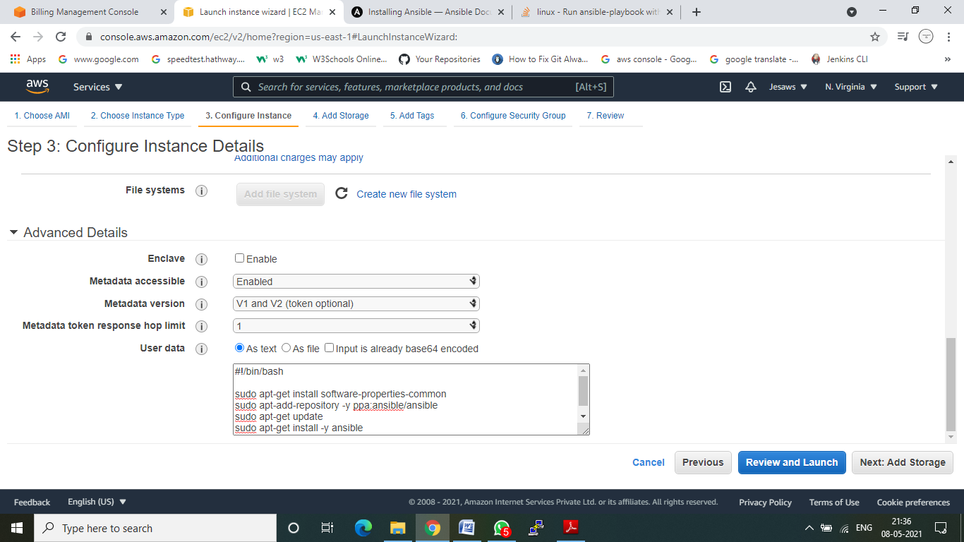

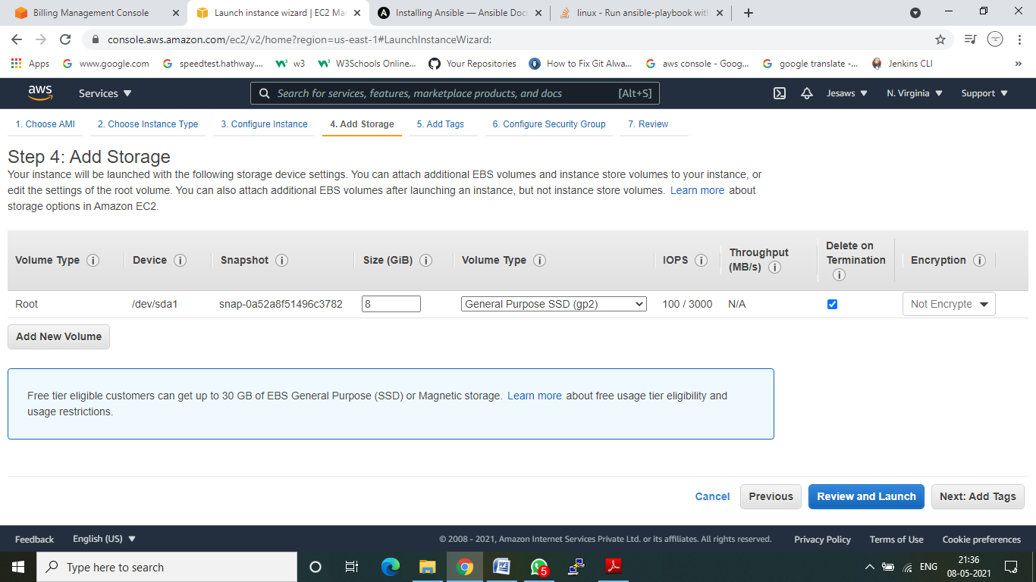

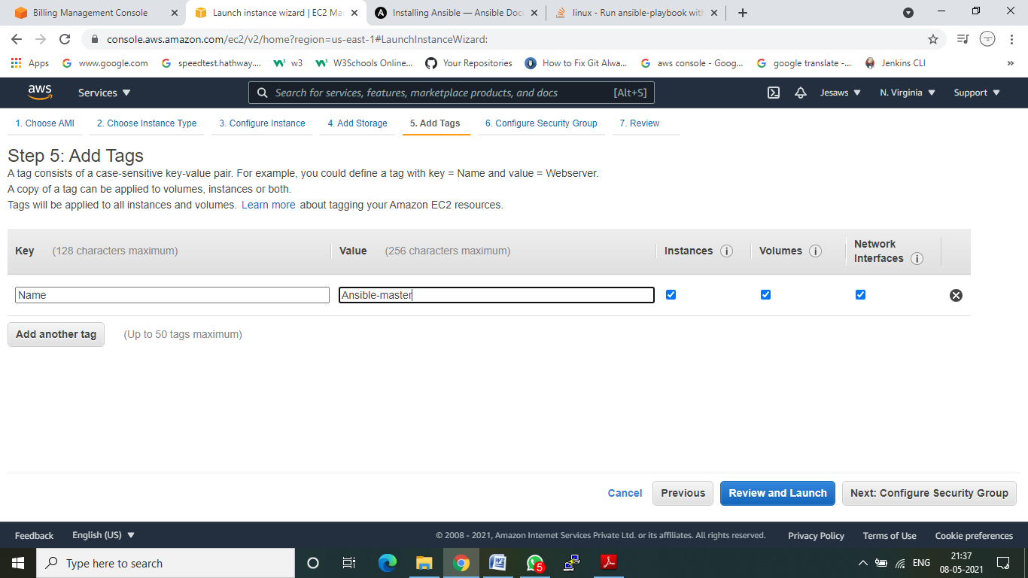

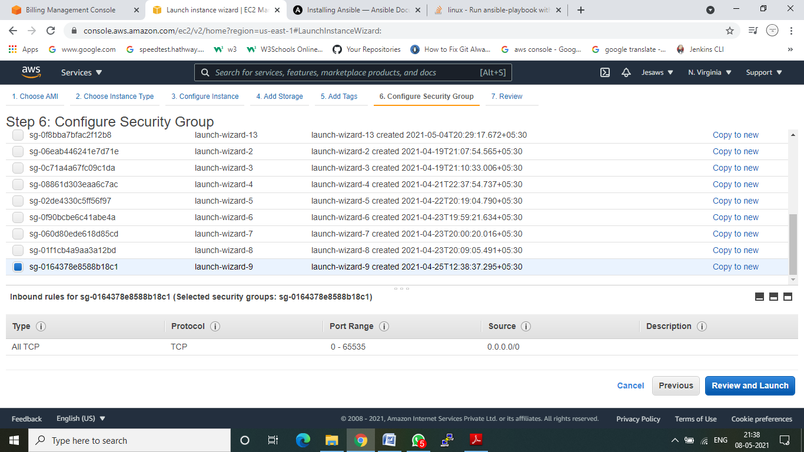

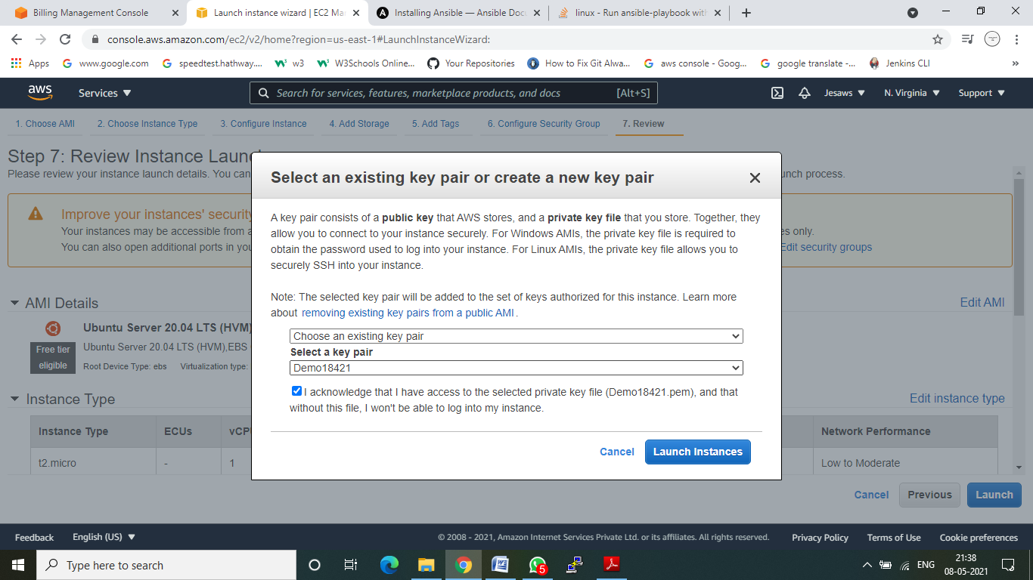

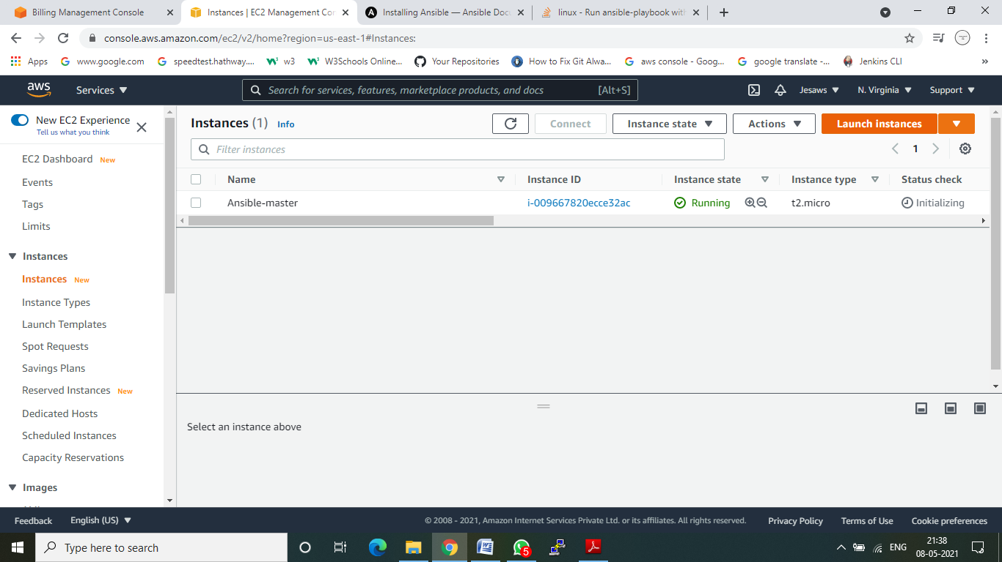

**Step 3:** Download Pageagent and load your ppk file.

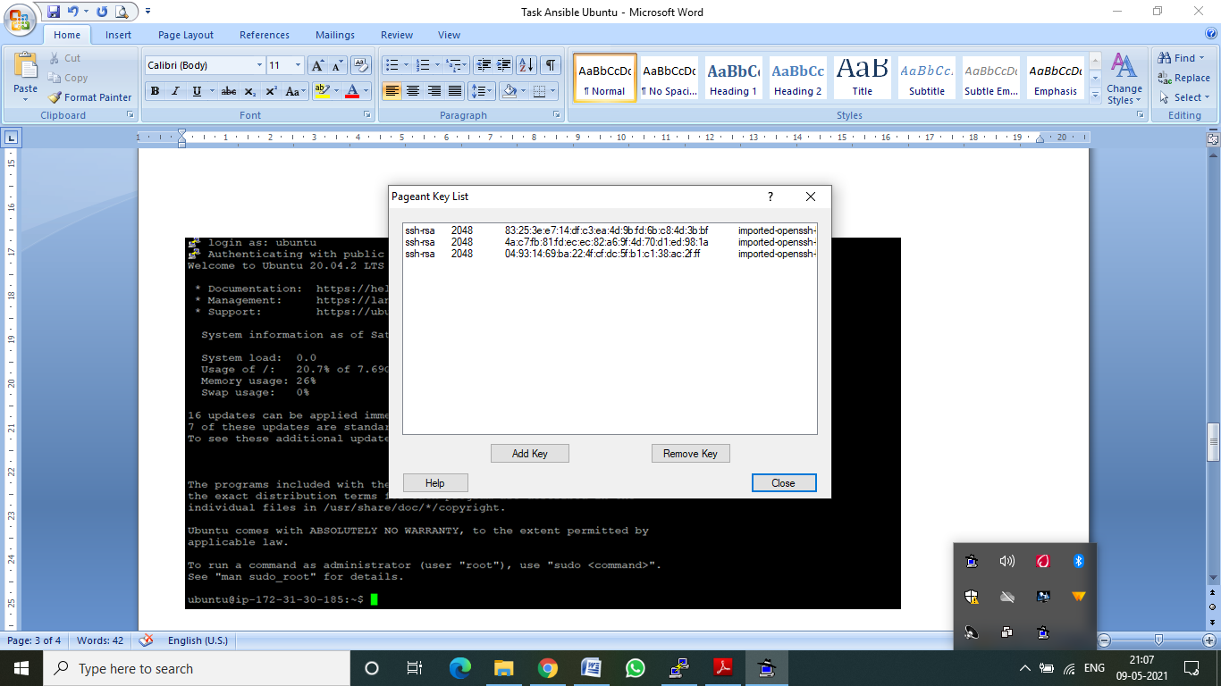



Using right click add the ppk file in the Pageagent:

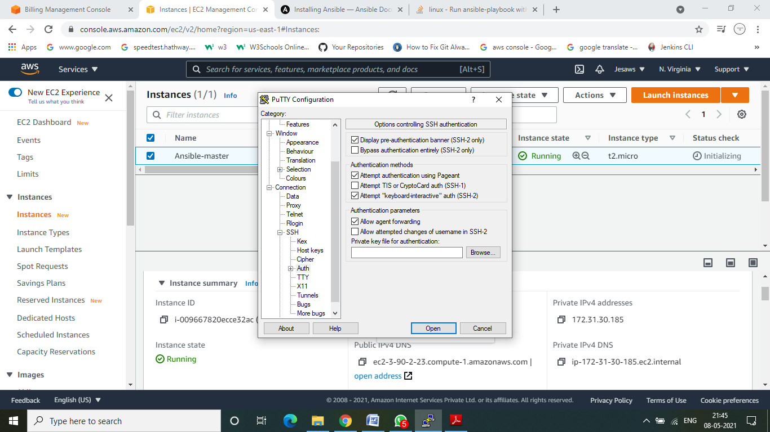

**Step 4**: In putty ssh session enable allow agent forwarding option- Otherwise while connecting to node instance you will get permission denied error

Logon to ubuntu

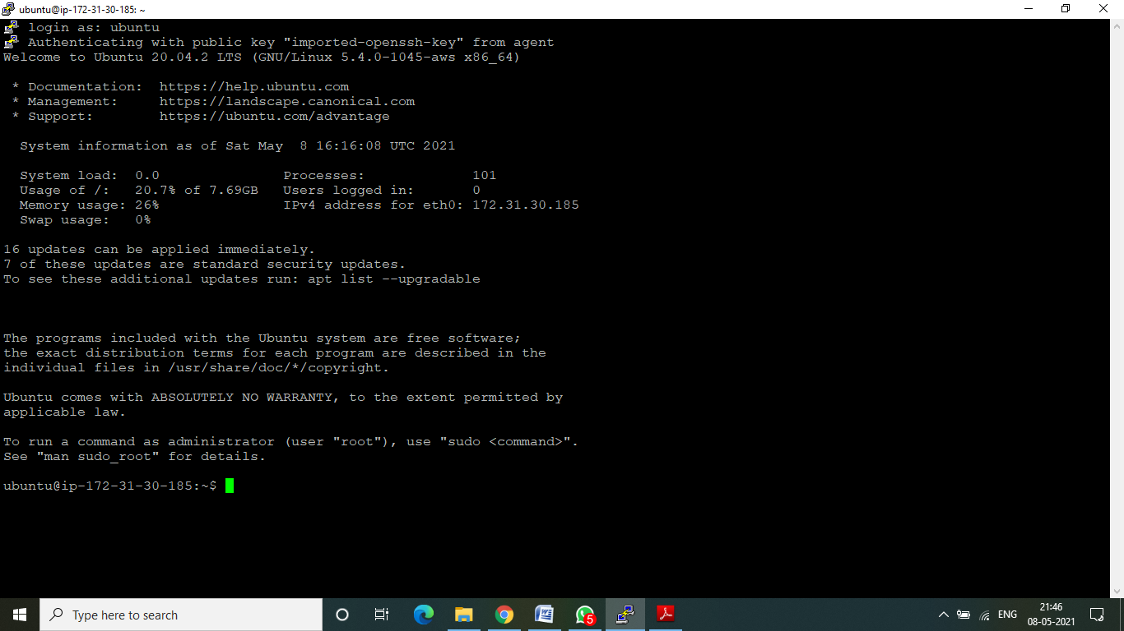

**Step 5:** Ansible adhoc command: Practice the command below with ubuntu user and not with root user

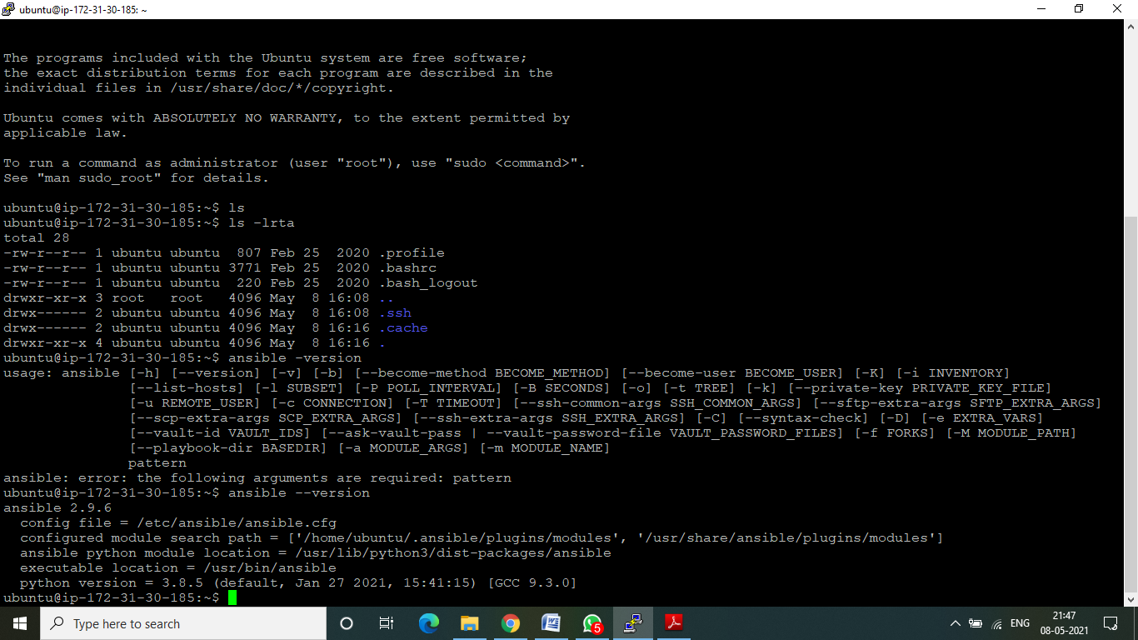

**Step 6:** Create one text file for e.g. slaves.txt and add node instance private IP

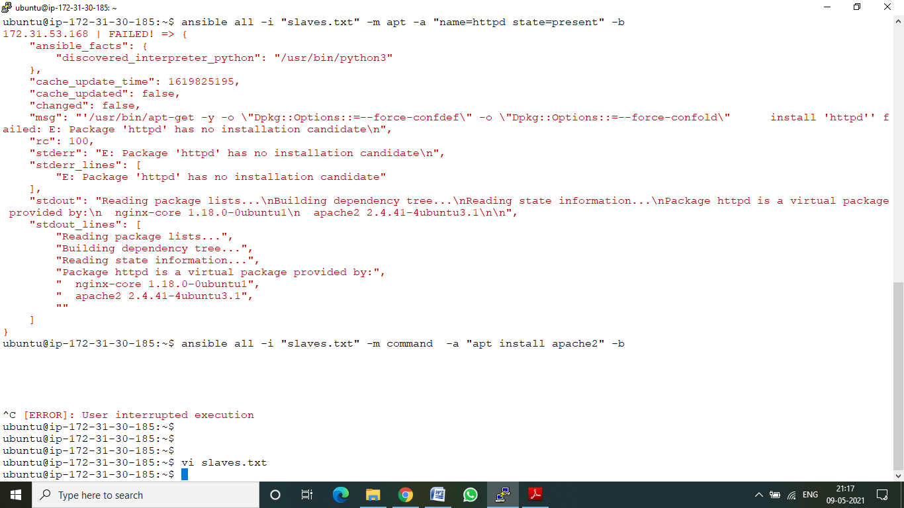



**Step 7:** Default creation of ansible.cfg file and u can get it from

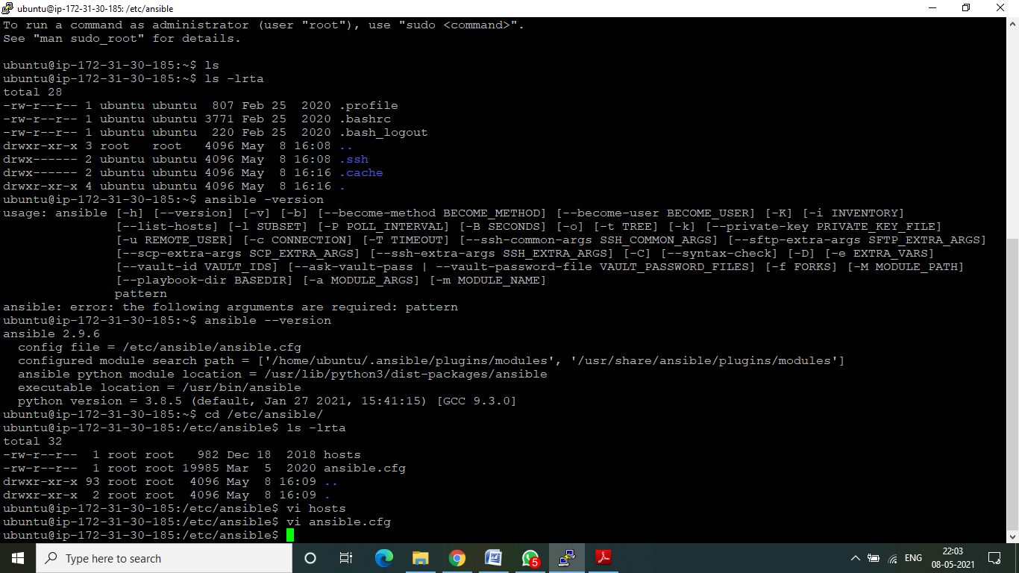

**Step 8: Vi ansible.cfg**

ubuntu@ip-172-31-30-185:~$ vi ansible.cfg

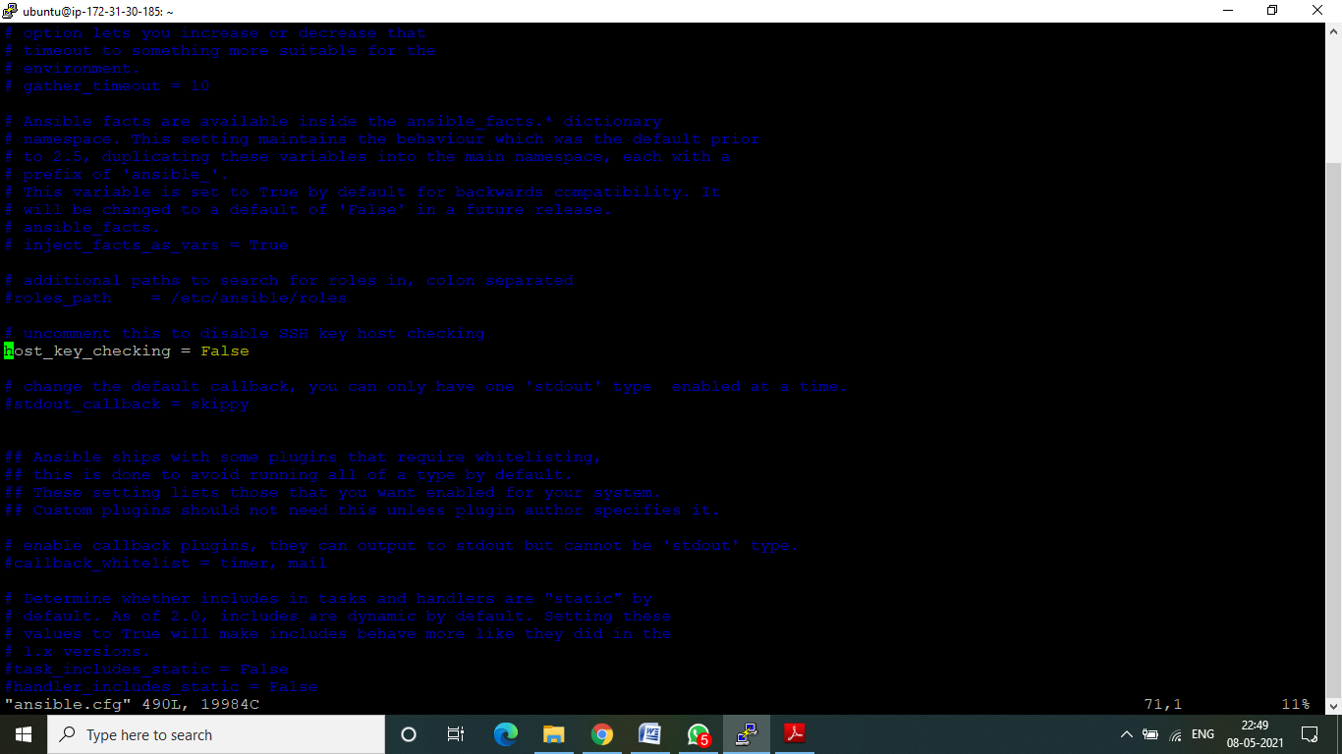

**Step 9: ansible all -i slaves.txt -m ping**

